
a
Company
Logotype

Cone Beam Computed Tomography- Report



Porur Dental X-rays & CBCT

Patient Name : Mrs. Muthuselvi | Date of Report : 25.03.2024
Age/ Gender : 47 years/ Female | Region of Interest : CBCT Sectional Maxilla
Referring doctor: Dr. Anjan | Indication : Implant assessment
Clinical Notes: Nil
PATIENT INFORMATION

CBCT- Sectional Maxilla provided
CBCT – IMAGE DETAILS

RADIOGRAPHIC INTERPRETATION

- Completely missing crown and root portion in relation to: 15, 16, 17, 18.
- The tooth 14 is present with hyperdense restorative material within the crown, extending upto the apical third of the root.
- The maxillary alveolar ridge is present with normal trabecular pattern.
 | 15 region | 16 region | 17 region
Sub-Crestal (in mm) | 7.1 | 9.07 | 7.3
Mid- Crestal (in mm) | 8.36 | 10.5 | 9.94
Distance between the alveolar ridge and floor of the maxillary sinus (in mm) | 9.63 | 15.5 | 12.66
IMPLANT ASSESSMENT

RADIOGRAPHIC IMPRESSION

- Partially edentulous maxillary arch.
- Root canal treated tooth : 14

Kindly correlate with clinical findings


IMAGES FOR REFERENCE

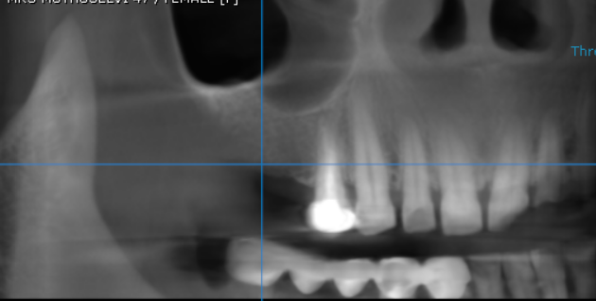

3-DIMENSIONAL VIEW

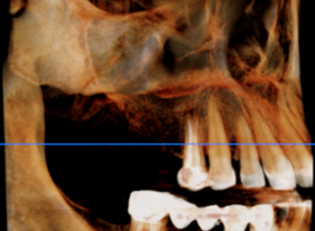

CROSS SECTIONAL VIEW

15 region | 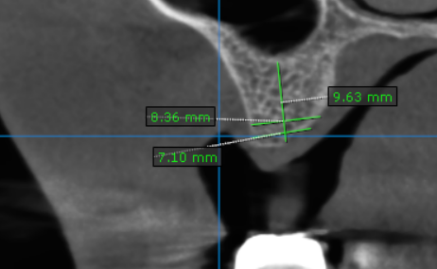
16 region | 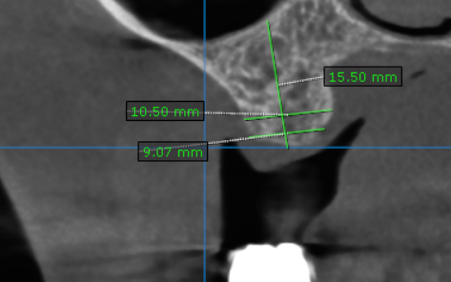
17 region | 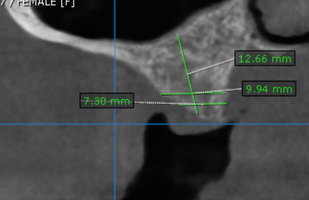

**** End of report ****

